# Lite Server

## How open terminal

Even though there is a graphical interface, everything can easily be done using the terminal. Accessing the terminal can be done in many ways. The easiest way of opening the terminal is simply pressing the combination buttons: ctrl + shift + t.

## Elevated commands

For some commands you will have to be super user. This can be done in two ways:

1. Either you use the sudo command, e.g. sudo cp –rf …
2. Or you log in as super user, e.g. sudo su

When using the first option, a password needs to be provided every time you use the sudo command. In the second option the password will only be asked for once. The second option is considered bad practice though and is unsafe since you are leaving your desktop with a user that can create/edit/delete everything without any limits.

The sudo password is: adminroot

## How update software

Copying the software on a thumb drive using the terminal is not very different than in a Windows environment. The only difficulty is finding the thumb drive. When a thumb drive is inserted you need to know what extension is being used. To discover this, you need to use the following command:

* df –h

The output will look something like this:

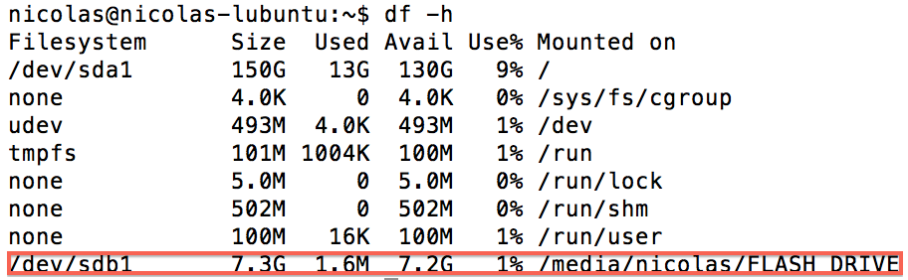

Recognizing which drive can be done in many ways:

1. First of all, a thumb drive is always in the directory “/media/”.
2. Furthermore, the name of the drive is listed as well as the capacity.
3. The filesystem will always be in the format “/dev/sdXX” where XX is a letter and a number.

In this case, the path to my thumb drive is /media/nicolas/FLASH DRIVE. This is the location where we will copy the software to. Now the copy process: the copy process is run as follows:

* sudo cp –rf [source] [destination]

Our software can be found under the Webapps folder in the Jetty folder. The working directory is: /home/nicolas/Downloads/Jetty/webapps/. Now we have all the information to do the update:

* sudo cp –rf /media/nicolas/FLASH\ DRIVE/PosServer .war /home/nicolas/Downloads/Jetty/webapps/

The extra \ is used to escape the white space in the name of the thumb drive. That’s it. The software has been updated!

This example was done with the software called PosServer.war. This can be anything of course. Typically this can either be PosServer, manager, partner with the war extension. It goes without saying the command needs to be altered with the right name, e.g. /home/nicolas/Downloads/manager.war.

## How update HTML templates

The HTML templates are always in the form xxxx.html where x is a number. First change to the usb directory, so:

* cd /media/nicolas/FLASH\ DRIVE/

Change this command to the USB name you use. To update them, simply do the following command:

* sudo cp 4245.html 4246.html 4247.html 4250.html [/root/posios/users/fod@posios.com_34/templates](mailto:/root/posios/users/fod@posios.com_34/templates)

Make sure this command is done elevated, so with sudo, else you will not have access to the directory.

## Starting the LiteServer

### How find what is using the 8080 port

It can be the case sometimes that port 8080 is used. If you’re not sure which process is using it, use the following command:

* netstat –pln | grep 8080

Warning: this command needs to be executed with elevated permissions. You will get an output like this:



The only thing remaining for you is to kill that process:

* kill -9 3287

3287 is in my case the PID of the process using the port 8080. If you’re not getting the PID, it means you did not use the command with sudo or as su.

### Starting the LiteServer

The LiteServer is easily started. The only thing you need to do is use the following command:

* /home/nicolas/Downloads/Jetty/startup.sh

Warning: this command needs to be executed with elevated permissions.

### Killing the LiteServer

The LiteServer can be killed in many ways. The easiest way to kill the LiteServer without having any hassle is simply killing the processes. To find the processes, use the following command:

* ps aux | grep –E ‘java|startup’

The output will look like this:



The second result does not matter. This is simply the process of giving the result a colour. The first one is indeed a java process and can be killed:

* kill -9 3287